PROJECT REPORT

KNIGHTS INN

Description:

MOTTO: Experience a Darj-chilling lifestyle.

Knights inn is a online travel website which allows to enjoy Darjeeling with no stress about restaurants, residence and travel guide. We provide you information about the visiting spots, restaurants and residence which will help to let you know about the Darjeeling in advance. We provide even the location of the restaurants and residence which will let you get the locality priorly.

Features:

About:

Knights inn provide you the details about the services along with the comfort they give customers with journey, luxurious residence and travel guide.

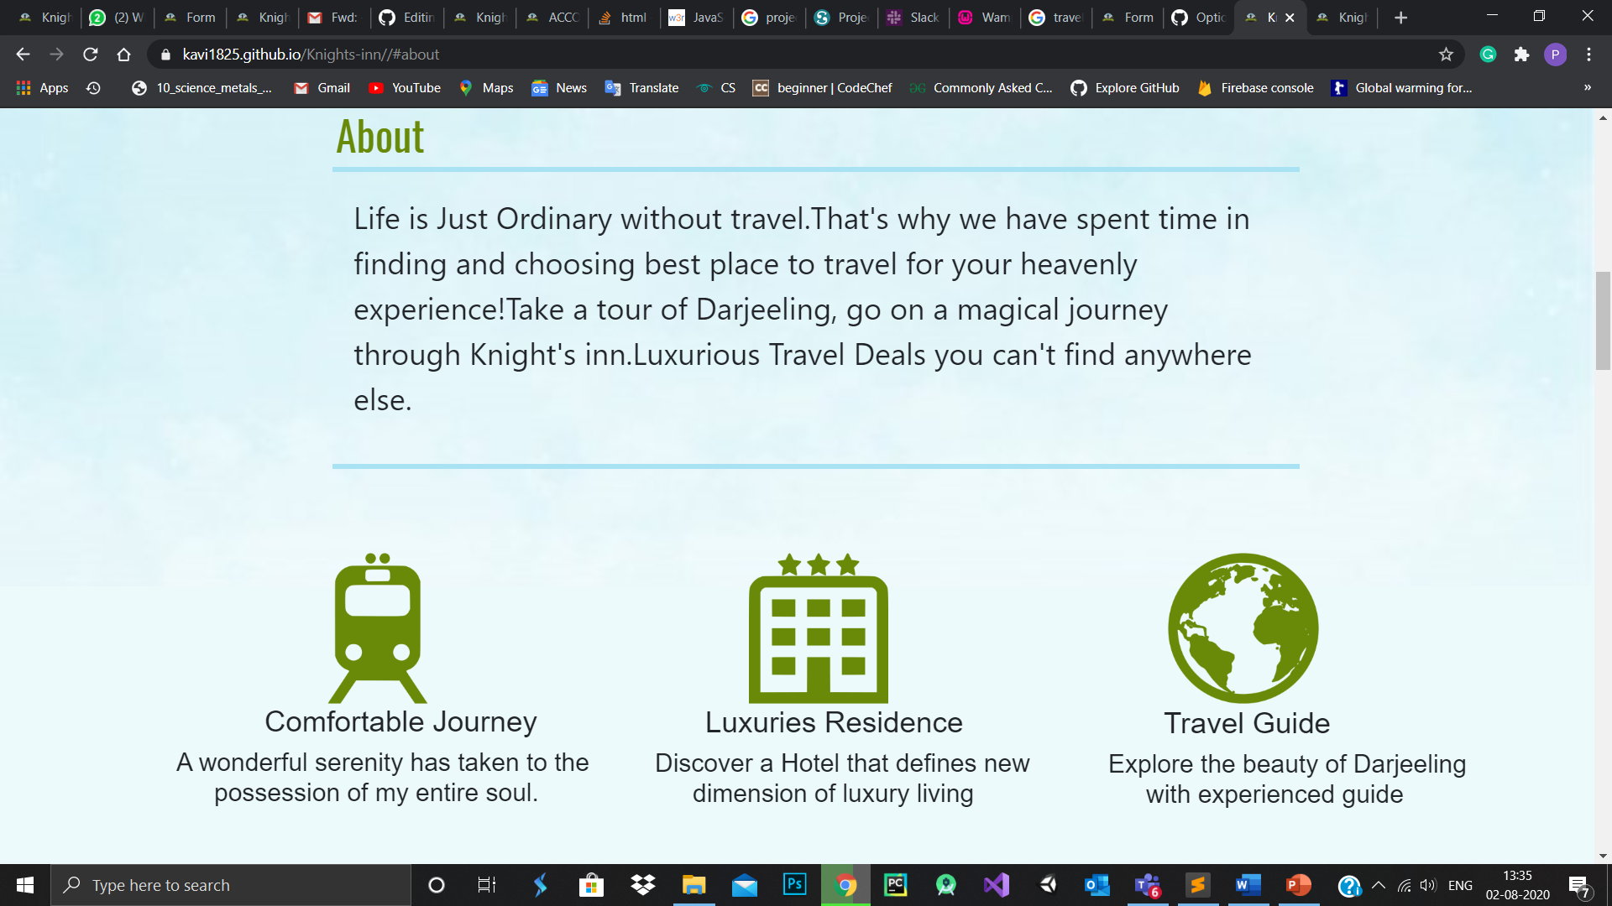

Visiting spots:

Darjeeling is a place of wonder where we have multiple tourist spots where we give them a sample of visiting spots to be visited which will attract the user and makes them to get ready for their trip.

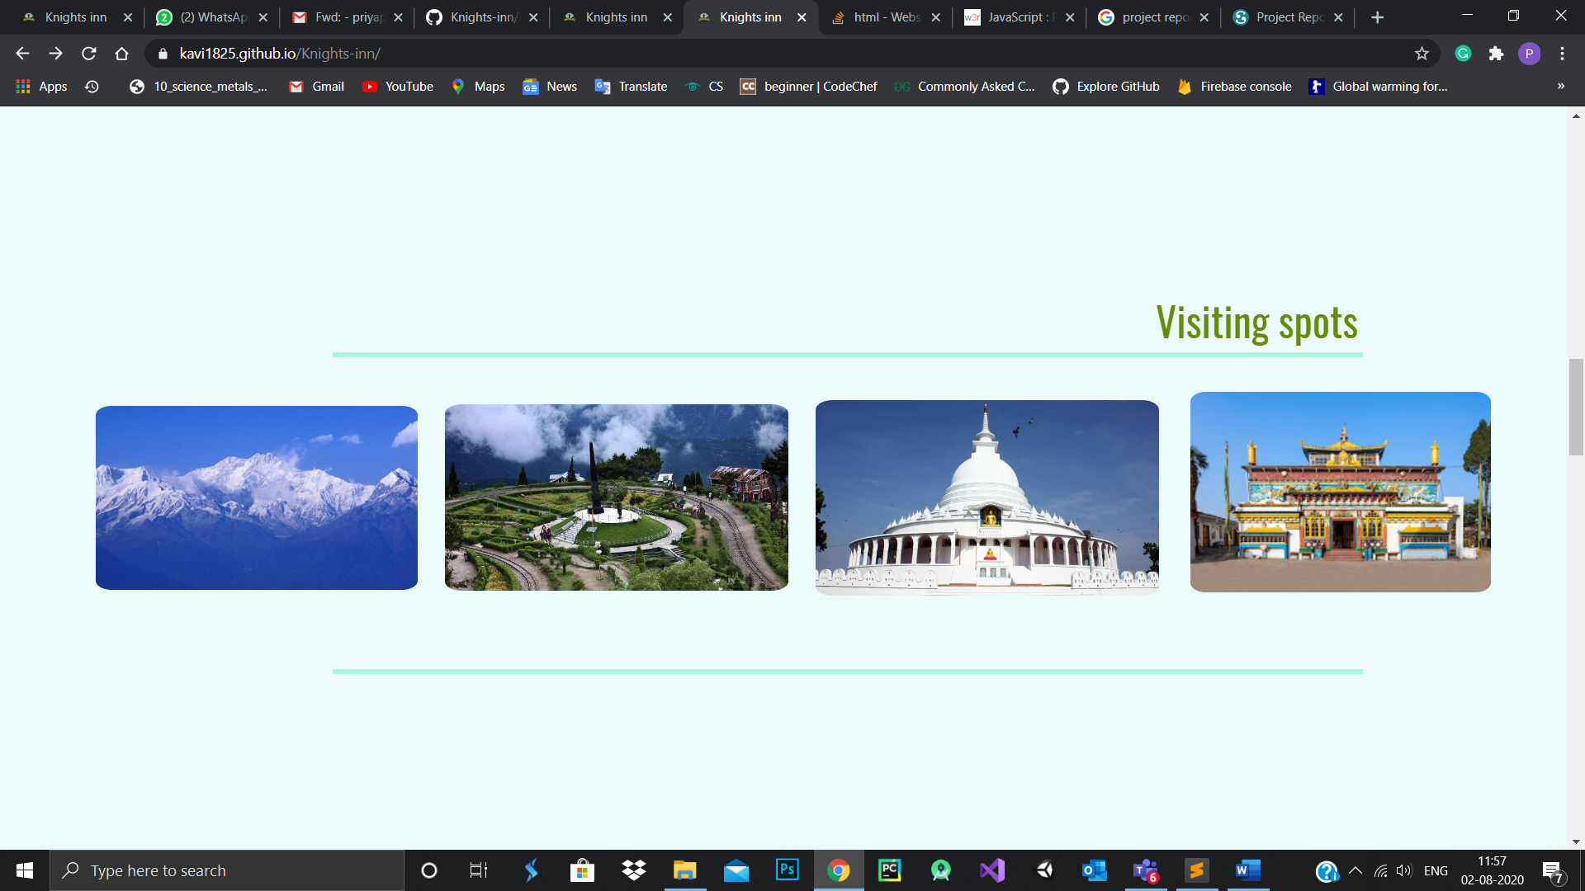

Residence:

The collection of good rated residence are provided by Knights inn where you could take a look at the residences available. Such that you need not rush or worry after reaching Darjeeling about the residence. The is interesting part is that we provide the residence along with the location using google map.

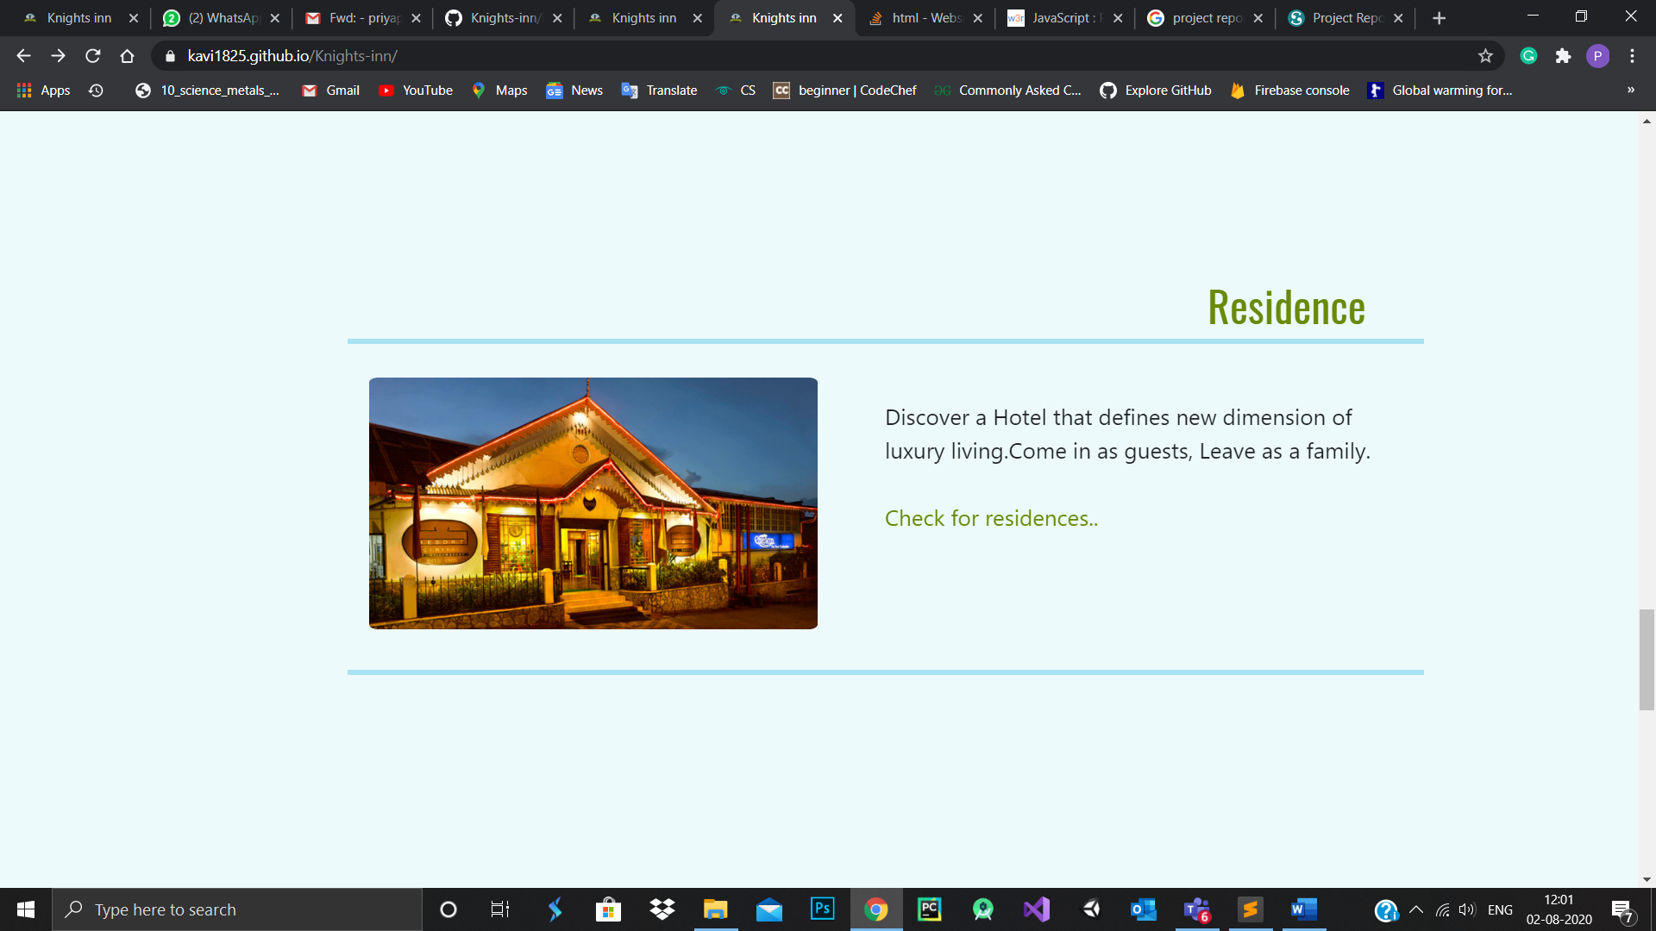

Restaurants:

Food makes the trip fulfilling, hence enjoy and explore the new and wide range of flavors make your taste buds wanting more. Hence Knights inn give you suggestion of the restaurants pick the once which impresses you.

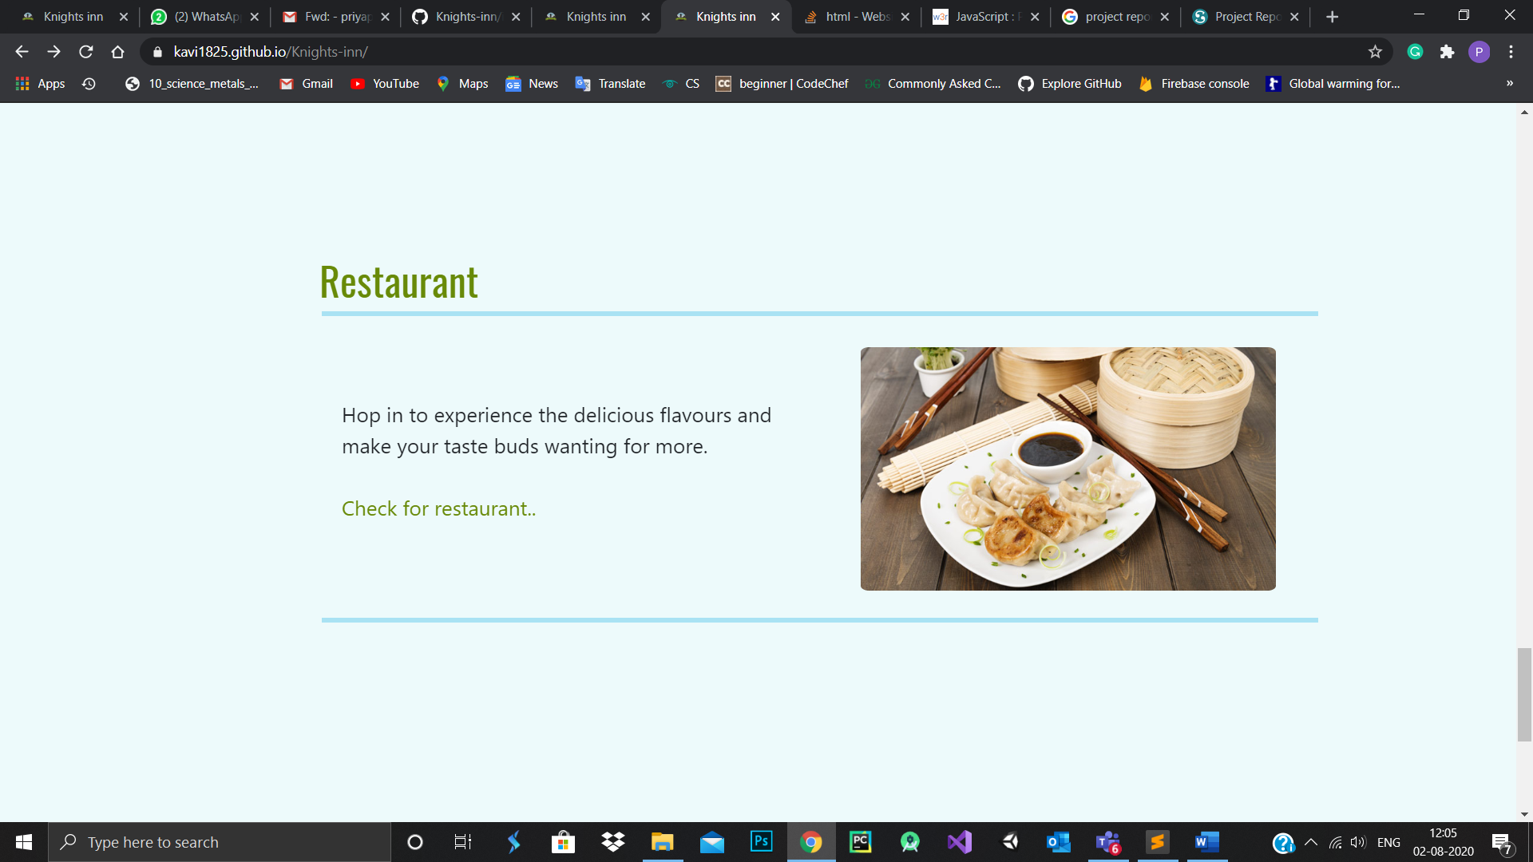

Booking:

Knights inn needs you to fill set of information which is not sensitive and we ensure the security of the data given. Hence the booking form will ensure your confirmation that you combined with Knights inn for wonderful journey. We provide a calculate package along with coupon for discount.

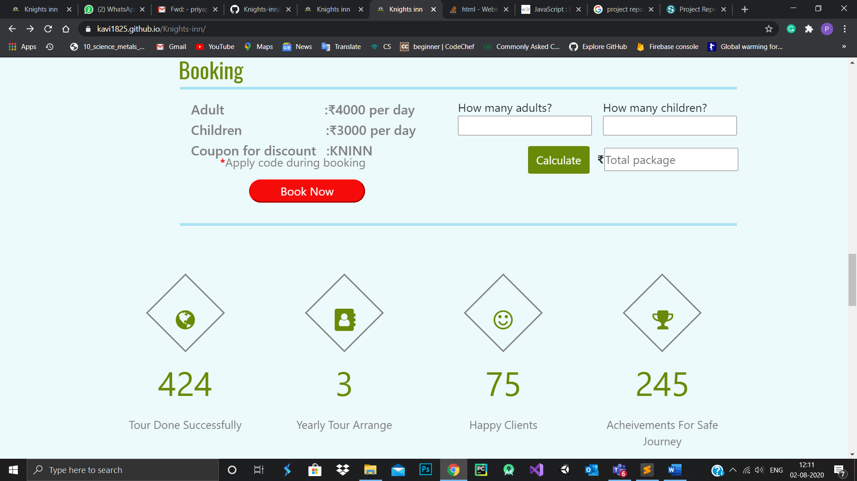

Tools & Technologies

* HTML
* CSS
* Programming Language: javascript
* Frame work: bootstrap
* IDE: Sublime text

User stories:

|  |  |  |  |  |
| --- | --- | --- | --- | --- |
| User story no: | As a | I want to | So that | Acceptance  criteria |
| 1. | Project team member | know all the requirements and tasks performed | The basic sketch of the website is prepared. | Website model and functionalities. |
| 2. | Project lead | Track the progress of the work. | The project is ready on time. | Website functioning |
| 3. | Web designer | Make sure fulfilling the given requirements | The outcome of the website becomes as expected. | Attractive webpage. |
| 4. | User | Give virtual experience of travel. | Get the clear idea about what is the travel experience | They are ready to pack their bags to explore. |

Project URL:

[https://kavi1825.github.io/Knights-inn//](https://kavi1825.github.io/Knights-inn/)